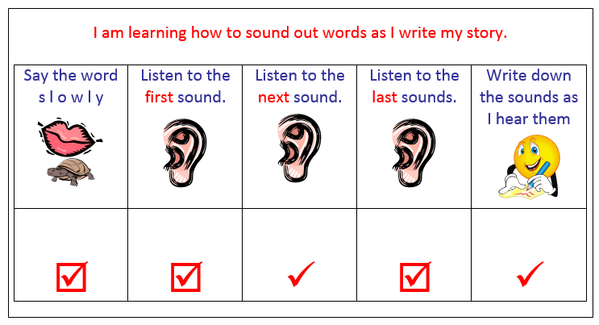 | Have my self-assessment sheet and writing book with me.
 | Tell my teacher what I have done well.
 | Show my teacher what I have done well.
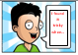 | Tell my teacher what I found tricky.
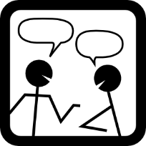 | Listen to what my teacher says to me.  Talk to my teacher about this.
Help me some more! | Tell my teacher if I need more help before I go back to finish my work.
 | Make changes to my writing to make my writing better.
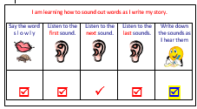 | Do my self-assessment again.
Barbara-Anne Alexander (b.alexander@evaluate.co.nz)

