Reflection

‘Who am I as a Learner?’

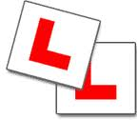
Barbara-Anne Alexander (b.alexander@evaluate.co.nz)
Evaluation Associates Ltd.
Who is in charge of your learning?
How do you show you are in charge of your learning?
What to learners do to become
GREAT Learners?

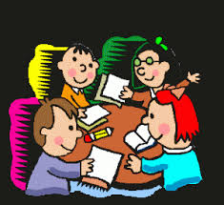
What are the important
messages about learning
you hear in our classroom?

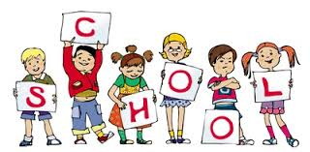
How do you contribute to what we learn and how we learn it?

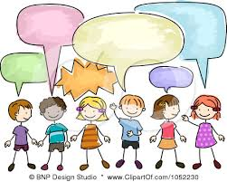
What could we do differently, to make the learning more engaging and enjoyable?

Is there someone who encourages or helps you with your learning?
Who? How?

What gets in the way of your learning and stops you giving your best?

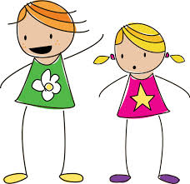

What could your teacher and/or buddies do, to help you
complete quality work?

