I have finished my self-assessment and made improvements? |  |  |  |  | Yes? | 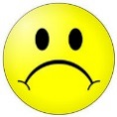  No?
 | and | ? | 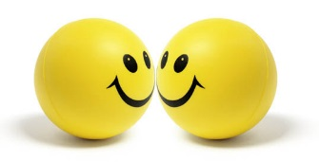 | ( )  or  ^
 | 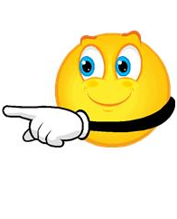
I am most proud of… | Show me and point. | I need help with… | We talk about our learning. | Make an improvement. | Let’s look at your self-assessment card again.

