SELF ASSESSMENT
A journey to empowering students with their learning

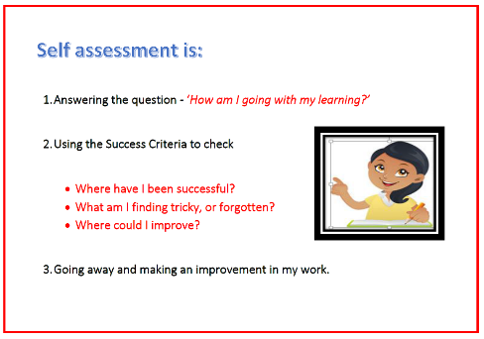
Teaching students to self-assess

- Start with Defining self-assessment
- What is it?
- Use student friendly language.

- Discuss with students – why we do it?
- The purpose of self-assessment i.e. how does this help us to be a great or powerful learner?
- That it is not about right and wrong – it’s about learning and improvement.

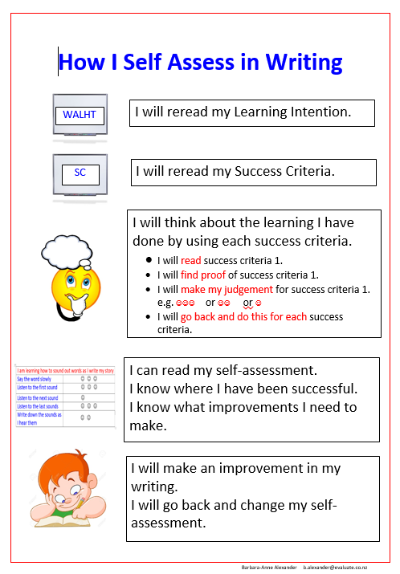
- Model the process of self-assessment, making deliberate links to a poster you have created. This is so students are able to follow a process by themselves when they are at the independent stage of self-assessment. (see number 7 below)

Modelling self-assessment to students

- Quickly review steps 1 and 2.

- Go over step 3 a couple of times, using your
model or a piece of student work.

Modelling self-assessment with student help

- Quickly review steps 1 and 2.

- Model self-assessment with student support
- Read the LI and SC together.
- Read SC 1.
- Model how to find evidence for SC1.
- Model how to make a decision/judgement for SC1 e.g. or or
- Perhaps create a poster of what each of the judgements mean.
- Read SC2.
- Tell students to find evidence of SC2 in their work. Have them talk to their buddy about the evidence they’ve found.
- One student comes up and highlights the evidence of SC2.
- Ask students in pairs to decide what they would give this piece of work.

or or
- Repeat the above process for all SC.

- Explain/scaffold students to read the self-assessment – what does it tell them? Where were you successful? What improvement do you need to make? What might you need help with?

- Model with students how to make a change to their work based on what the self-assessment tells them.

Scaffold students with self-assessment

- Quickly review steps 1 and 2.

- In a small group, scaffold students with self-assessment
- Direct them to read the LI and SC by themselves (in their heads).
- Direct them to go through the above bullet points in Step 7, monitoring them as they go.

Students independently self-assess

- By themselves
- Students follow the self-assessment process you have been modelling and scaffolding them through. It is a routine step in the writing process. Students know they are expected to self-assess when they finish their writing.

- Use a prompting card to remind them to self-assess their writing during the writing process.

