**How to be a CHAMPION Learner**

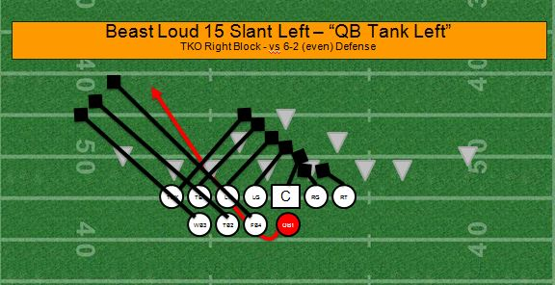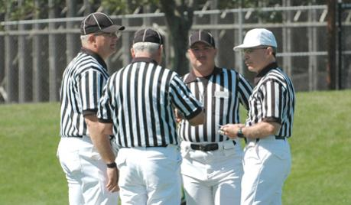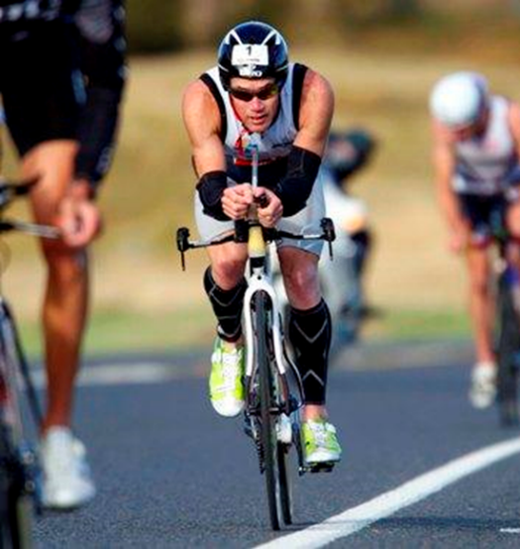

**We can listen to our mates’ ideas.**

**We can work in a team or by**

**ourselves to be successful.**

**We tackle our learning by putting what we learn into practice.**

**We bowl each other over by sharing our ideas.**

**We come up with creative ways to show our understanding.**

**We reach our learning goals by staying focused.**

Rob Doolan, Yr 3

Mellons Bay School