|  |  |
| --- | --- |
| **…………………… School** | **Mid-year/End of year report [Month and year]** |

additional

**Student name Year Level Room**

The purpose of this report is to tell you about …………….’s progress and achievement at school this year.

As year …… students, ……………… and his/her class are working towards level ………. of the New Zealand Curriculum in the learning areas of the curriculum (Literacy, Mathematics, Science, The Arts, Health and Physical Education, Social Science, Technology, Learning Languages.) In this report you will find specific comments about these learning areas.

This is ……………’s ………. year at school in New Zealand and s/he is still working at becoming proficient in English. His/her current level of attainment means that s/he is still working towards meeting the year ……. National Standards for reading and writing. We are reporting his/her progress and achievement in reading, writing and oral language in English using The English Language Learning Progressions (ELLP). These progressions are designed for students who are learning English as an additional language.

Students of ………….’s age usually progress through four stages as they learn English and reach the age-appropriate level; that is Foundation, Stage One, Stage Two and Stage Three.

To decide on ……….’s Stage on the English Language Learning Progressions we use information we have gathered over the year.

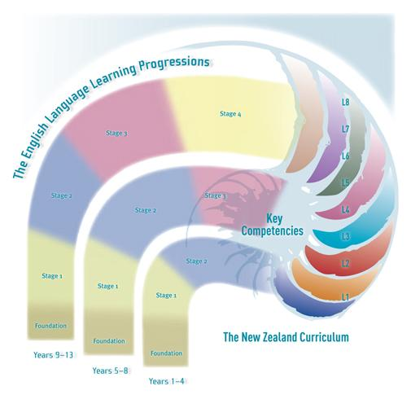

Could include a photograph of …………. at school in this space.

|  |  |
| --- | --- |
| Oral Language ……………. is currently working at **Stage …** of *The English Language Learning Progressions* | |
| (Narrative about student’s achievement to date) | |
| Next steps for …………………………. | What you can do to support your child’s learning. |

|  |  |  |
| --- | --- | --- |
| Reading ……………. is currently working at **Stage …** of *The English Language Learning Progressions* | | |
| (Narrative about student’s achievement to date) | | |
| Next steps for …………………………. | What you can do to support your child’s learning. |

|  |  |  |
| --- | --- | --- |
| Writing …………………. is at Stage **………………….** of The English Language Learning Progressions | | |
| (Narrative about student’s achievement to date) | | |
| Next steps for …………………………. | What you can do to support your child’s learning. |

|  |  |
| --- | --- |
| Mathematics ……………. is working at **Level …** of the New Zealand Curriculum | |
| (Narrative about student’s achievement to date) | |
| Next steps for …………………………. | What you can do to support your child’s learning. |

|  |
| --- |
| ShellOther Learning Areas – Topics and units of work studied in the New Zealand Curriculum  (The Arts, Health and Physical Education, Learning Languages, Science, Social Science, Technology) |
|  |
| General Comments: |
| (Narrative about student’s involvement and achievement) |

|  |
| --- |
| School activities/Responsibilities/Achievements |
|  |

|  |
| --- |
| Key Competencies/School Values |
| Me as a learner (written by student) |
| *I have improved in…*  *I know this because….*  *I now need to ……* |

Signed

Teacher ____________

Principal ____________