## Things that help me learn

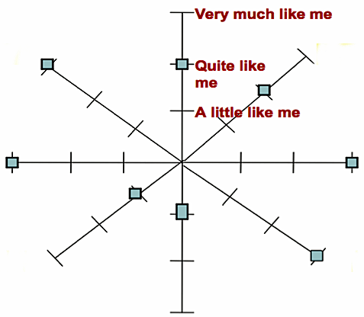

*Text goes here*

*Text goes here*

*Text goes here*

*Text goes here*

*Text goes here*

*Text goes here*

*Text goes here*

*Text goes here*