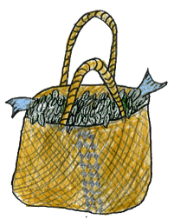**Room 4 students are weaving their way to Learning success**



Challenge ourselves to expand our knowledge and continue to grow. See every opportunity as a learning one.



Be resilient and show strength when faced with challenges. Be proud of our success and accept our failures.



Be luminous and reflective - think about where we are going with our learning and where we need to go next.



Aim and work hard to achieve the goals we set ourselves, keep a positive attitude.

[](http://www.google.co.nz/url?sa=i&rct=j&q=&esrc=s&frm=1&source=images&cd=&cad=rja&docid=mkspeiYQ6lp-eM&tbnid=0qsHB5P4aLYv4M:&ved=0CAUQjRw&url=http://www.energyworksnz.co.nz/index/page/Synergens_-_Natures__Healing_Pharmacy&ei=me0KU8ecCpGJlQWpuIC4DQ&psig=AFQjCNGvciW4b3LQRk2S5fKWM-MP7vY1Aw&ust=1393311470069827)

Display focus and concentration when we are approaching our tasks.

Are approaching our tasks

Sustainability-be consistent in your work habits.

Maintain and sustain. Be consistent in our work habits and uphold our right to learn.

