**Thinking about ‘Who am I as a Learner?**



**Julie Cooke**

**Greenhithe Primary School**

**Who is in charge of your learning?**

**C:\Users\juliec\AppData\Local\Microsoft\Windows\Temporary Internet Files\Content.IE5\1W19YCZU\MC900438229[1].wmf**

**How do you show that you are in charge of your learning?**

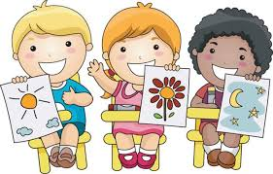

**What do great learners do?**



**What is the next thing you need to do for your learning?**

**C:\Users\juliec\AppData\Local\Microsoft\Windows\Temporary Internet Files\Content.IE5\NKE30D8Y\MC900445118[1].wmf**

**Have you come ready for learning?**

**Are you sitting next to someone who will support your learning?**

**C:\Users\juliec\AppData\Local\Microsoft\Windows\Temporary Internet Files\Content.IE5\APD7CF0L\MC900445734[1].wmf**

**What were you learning today? How do you know that you have learnt it?**



**What do you need to do to help you learn?**

**C:\Users\juliec\AppData\Local\Microsoft\Windows\Temporary Internet Files\Content.IE5\1W19YCZU\MC900232133[1].wmf**

**Turn to a friend. Tell them two things that you have learnt this week.**

