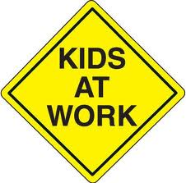
Room 12 are great learners.
To be a great learner you need to:

Believe in yourself—you can do it.
Ask for support if you need it.
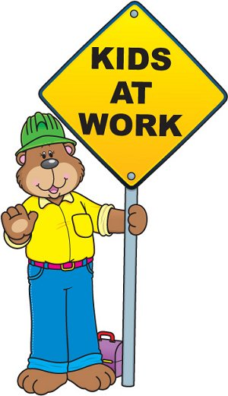
Know that learning is a journey.
Stay focussed.
Reflect on learning.
Manage yourself – you are in control of your own learning.

