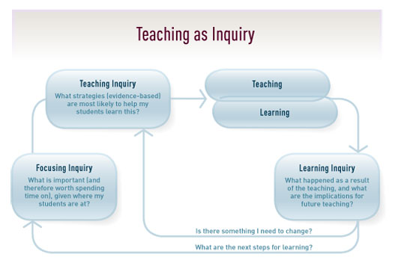

Name: _____________________________________ Date:________________________

Barbara-Anne Alexander (b.alexander@evaluate.co.nz)
Evidence and Data Gathering on proposed inquiry focus-
What evidence do I have to inform my inquiry? What do I know about how engaged my students are in a learning focused relationship? What have I already unpacked with my students? What was the result of this?

My students seem quite passive as learners, and they were unable to verbalise the messages I thought I had given them. They are learning, but are not actively involved in the learning process and are quite reliant on me to keep them on task. Their response to the interview question was ‘You need to sit up and listen to the teacher. We work quietly and do what we are told. Work hard and write lots of pages. Try your best’.

Focusing Inquiry-
What is important (and therefore worth spending time on), given where my target students are at?

To strengthen the learning focused relationships in my classroom and how my students see themselves as learners.

Teaching Inquiry-
What strategies (evidence based) are most likely to help my students learn this? What are your theories of improvement? What could make a difference to the LFR in your classroom?  - Think through and display the six top messages I want my students to understand and be able to talk about.  - Brainstorm learning and do a Y chart to get further baseline information.  - Write a simple definition of learning with my students so that when we use this word we have a common language.  - Discuss with students that the classroom is a learning zone, where active learning is expected door sign -welcome to Room 11, you are now entering a learning zone.  - Metaphor for learning - what best suits our classroom. One suggestion – ‘Learning is Mission Possible’.  - Start to unpack my 6 key messages about learning with the classroom – what is it? What does it look like when it is present? Take photos of students exemplifying these qualities. Celebrate and reinforce when I or peers see this happening.  - Find some key quotes online that exemplify the above qualities.  - Regular 2 min brainstorms about what is learning and who are we as learners.  - Discuss what bugs them or distracts them as a learner. Take this further what could they do about this? Give them permission to have a voice with peers – Stop that you are bugging my learning.  - Ensure there is a common language of learning e.g. LI, SC, Relevance, modelling, example | What knowledge/skills do I need to build in order to support my inquiry?  - Read Chapter 2 and 3 of ‘Clarity in the Classroom’ by Michael Absolum.  - Visit some of the classrooms in our school to see how teachers are visually representing learning in their classrooms.  - Share my inquiry at my QLC and listen to others to see if other teachers have tried things which have worked for them and could work for me.
Teaching-
What will I do differently from the teaching inquiry box? Date and give a small summary of what you will do.

July 11 – Begin with the items highlighted in yellow.

July 26 – Beginning with the items highlighted in green.
Learning-
What will students do differently based on what you will do differently? Date and give a small summary of what they will do.
July 11 – I want students to have
- a shared understanding of learning and what it means to be a learner.
- see the classroom as a learning zone, where learning happens and with that certain learning behaviour – being engaged, sitting somewhere where they are not going to be distracted and begin to take more responsibility for their learning.

July 26 – I want students to
- unpack what being ready means – bag unpacked, book for the first bit of learning on their desk, seated in a learning position on the mat, I have all the equipment I need, I expect to learn something new, I expect the teacher to be ready and share and explain the LI, relevance, SC and a model. I can ask if that isn’t there for them. I am hoping out of this brainstorm, other criteria for being ready will come out.
Learning Inquiry-
At specific times, stop, notice, recognise and reflect on how things are going. What happened as a result of the teaching, and what are the implications for future teaching? Is there something I need to change? (Go back to the ideas you have in your teaching inquiry box). What are the next steps for learning? (What is the new focus for your next inquiry?).

July 25 – Thinking of my six top messages for learning was harder than I thought. I have come up with four so far and I am hoping the other two will come out of the regular brainstorms and discussions. So we have begun looking at Be ready! Be engaged! Take responsibility! Take risks – make mistakes and learn from them. When we talked about coming up with a door sign, students were happy with Welcome to Room 11, you are now entering a learning zone. Their suggestion was to have their photos around the sign.
August 7 -

