Learning Intention
I am learning how to write a story in order
Success Criteria
I will know I am successful when I:

Write about what happened first.

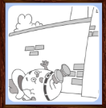
Write about what happened next.

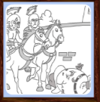
Write about what happened after that.

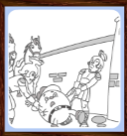
Write about what happened at the end.

Use time words like
Then, next, after that, finally, the next day...

