Learning Intention-
I am learning how to write a story.
Success Criteria-
I will know I am successful when:
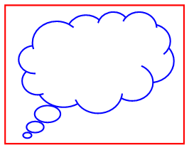
- I can think about a story to write.

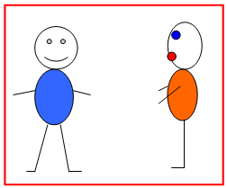
- I can tell my story to a friend or the teacher

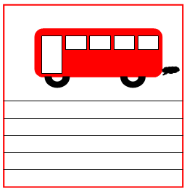

- I can draw a picture for my story.

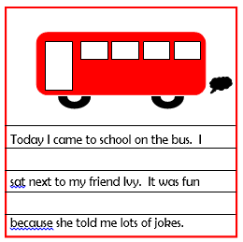

- I can write a story about my picture

- I can read my story to my friend and teacher

