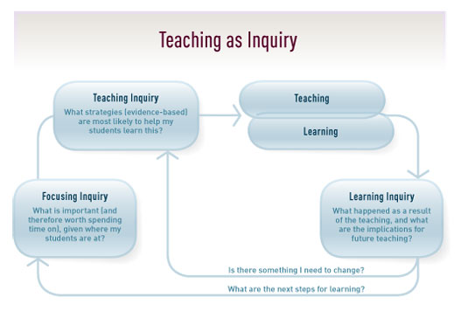

Name: _____________________________________ Date: ________________________

Evidence and Data Gathering on proposed inquiry focus
What evidence do I have to inform my inquiry? What do I know about my target students? What have I already tried with my target students? What was the result of this?

Focusing Inquiry
What is important (and therefore worth spending time on), given where my target students are at?
To accelerate the learning of my target students through …

Teaching Inquiry
What strategies (evidence based) are most likely to help my students learn this? | What knowledge/skills do I need to build in order to support my inquiry?
Teaching
What will I do differently, from the teaching inquiry box? Date and give a small summary of what you will do.

Learning
What will students do differently, based on what you will do differently? Date and give a small summary of what they will do.

Learning Inquiry
What happened as a result of the teaching, and what are the implications for future teaching? Is there something I need to change? (Go back to the ideas you have in your teaching inquiry box). What are the next steps for learning? (What is the focus for your next inquiry?).

