**How I Self Assess in Writing**

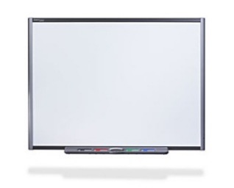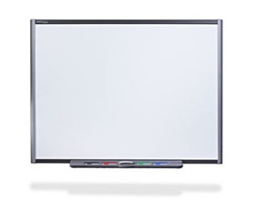

I will reread my Learning Intention.

WALHT

I will reread my Success Criteria.

SC

SC



I will think about the learning I have done by using the success criteria one by one.

* I will read SC 1.
* I will find proof of SC 1.
* I will make my judgement for SC 1.

e.g. ☺☺☺ or ☺☺ or ☺

* I will go back and do this for all the success criteria.

I can read my self-assessment.

I know where I have been successful.

I know what improvements I need to make.

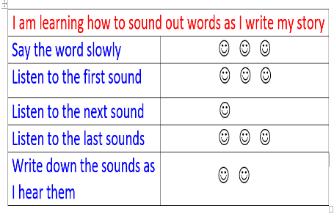

I will make an improvement in my writing.

I will go back and change my self-assessment.