Template 2: Report for a student learning English as a second language

(Click on the dots and arrows below to move them).

Area | Foundation A | Foundation B | Stage 1 | Stage 2 | Stage 3  Key  Your child’s achievement  Your child’s progress over the last year
Reading |  |  |  |  | 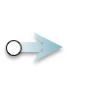
Writing
Strengths  Text goes here | Next steps  Text goes here

