How I Self Assess in Reading
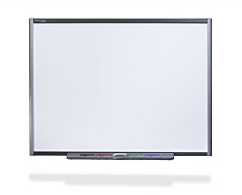
I will reread my Learning Intention.
WALHT
I will reread my Success Criteria.
SC
I will think about the learning I have done in reading today.
I will do my self assessment.
I am learning how to predict what the story might be about.
I can look at the title.
I can look at the picture on the cover.
I can look at the pictures inside the book.
I can make my smart guess
Barbara-Anne Alexander b.alexander@evaluate.co.nz
I can use my self assessment to tell somebody what I need to get better at in my reading.

