**I am learning how to work out a word I do not know**

**To be successful I will:**



**Read up to the word I do not know.**

**Look at the first letter.**

**Here is a house.**







**Look at the picture.**



**Read the sentence again**

**Here is a house.**

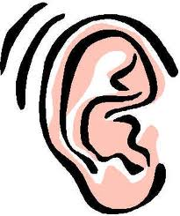

**Does it sound right? Does it make sense?**

Barbara-Anne Alexander (b.alexander@evaluate.co.nz)

Barbara-Anne Alexander (b.alexander@evaluate.co.nz)