**Teaching**

**Teaching Inquiry**

**Learning**

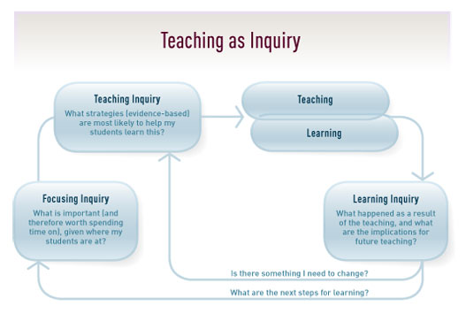

**Learning Inquiry**

**Focusing Inquiry**

**What are the next steps for learning?**

**Is there something I need to change?**